Individual Task - Module - 1

Foundations of AI:Historical Milestones &Core Concepts

1)Research and Present a timeline showing major milestones in AI History
Introduction:
• Artificial Intelligence (AI) is a rapidly growing field of computer science that focuses on creating
intelligent machines capable of performing tasks that normally require human intelligence.
• These tasks include learning from experience, reasoning, problem-solving, understanding
natural language, and making decisions.
• Studying the history of Artificial Intelligence helps us understand how human intelligence
inspired machines and how AI evolved from theoretical concepts into real-world applications.
• The following timeline explains the major milestones in the history of Artificial Intelligence along
with suitable examples.

Early Ideas and Foundations (Before 1950) :
• Before the invention of modern computers, humans imagined intelligent machines through
philosophy and mechanical inventions.
• Ancient Greek philosopher Aristotle introduced logical reasoning, which later became the
foundation of algorithms and decision-making systems.
• Example: Early calculating machines and mechanical clocks demonstrated how machines
could perform repetitive tasks accurately, inspiring future intelligent systems.

1950 – Alan Turing and Turing Test :
• In 1950, British mathematician and computer scientist Alan Turing published a groundbreaking
paper titled 'Computing Machinery and Intelligence.'
• He posed the famous question: 'Can machines think?' and proposed the Turing Test to
determine whether a machine can exhibit intelligent behavior similar to a human.
• In the Turing Test, a human evaluator communicates with both a machine and a human
through text. If the evaluator cannot reliably distinguish the machine from the human, the
machine is considered intelligent.
• Example: Modern chatbots and virtual assistants are inspired by the idea of the Turing Test.
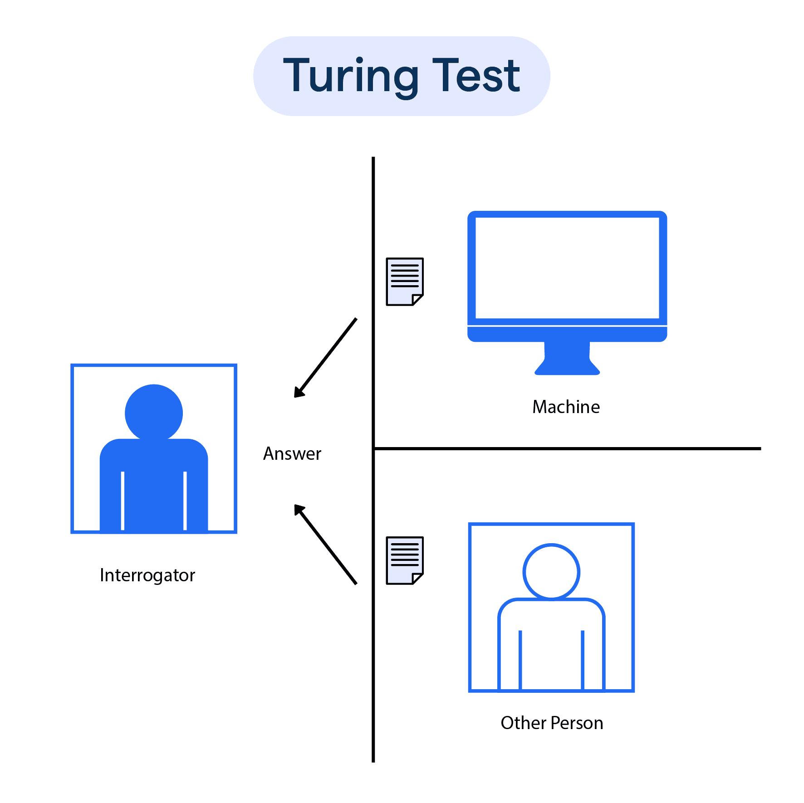

1956 – Birth of Artificial Intelligence :
• The term 'Artificial Intelligence' was officially introduced in 1956 during the Dartmouth
Conference organized by John McCarthy and other researchers.
• This conference marked the formal birth of Artificial Intelligence as an academic and research field.
• Example: Early AI programs could solve logical problems and play simple board games using
predefined rules.

1960s–1970s – Early AI Programs :
• During this period, AI research focused mainly on symbolic and rule-based systems.
• Notable programs included ELIZA and SHRDLU.
• Example: ELIZA acted as a simple virtual therapist by responding to user input using pattern
Matching.

AI Winter (1970s–1980s) :
• Despite early optimism, AI research faced challenges such as limited computing power, lack of
large datasets, and unrealistic expectations.
• As a result, funding for AI projects was reduced, leading to a period known as the 'AI Winter.'
• Example: Early speech recognition systems failed due to noise and limited processing
capabilities.

1980s – Expert Systems Era :
• AI research revived with the development of expert systems.
• These systems used a knowledge base and inference rules to make decisions similar to human
experts.
• Example: Medical expert systems assisted doctors by suggesting possible diseases based on
symptoms.

2000s – Big Data and Improved Computing:
• The growth of the internet led to the availability of massive amounts of data known as Big Data.
• Combined with improved computing power and storage, this enabled AI systems to become
more accurate and efficient.
• Example: Google Search uses AI algorithms to provide relevant search results.

Modern AI and Ethical Considerations (Present Day)
• Today, Artificial Intelligence is widely used in healthcare, education, finance, transportation, and
entertainment.
• Technologies such as chatbots, autonomous vehicles, and generative AI are transforming
society.
• Example: AI-based recommendation systems on YouTube and Netflix personalize content for
users.

